**Daily Expense Tracker System**

by

CHAKSHU JINDAL 15BCE1375

UMAKANT JENA 15BCE1376

A project report submitted to

**Dr. S. Ganapathy**

**SCHOOL OF COMPUTER SCIENCE AND ENGINEERING**

in partial fulfilment of the requirements for the course of

**CSE3001 –SOFTWARE ENGINEERING**

in

**B.Tech. (COMPUTER SCIENCE)**



**VIT UNIVERSITY, CHENNAI**

**Vandalur – Kelambakkam Road**

**Chennai – 600127**

**NOVEMBER 2016**

**BONAFIDE CERTIFICATE**

Certified that this project report entitled “**J & J Daily Expense Tracker System ”** is a bonafide work of CHAKSHU JINDAL 15BCE1375, UMAKANT JENA 15BCE1376 , who carried out the “J”-Project work under my supervision and guidance.

**Dr. S. Ganapathy**

Associate Professor

**SCHOOL OF COMPUTER SCIENCE AND ENGINEERING**

VIT University, Chennai

Chennai – 600 127.

**ABSTRACT**

J & J Daily Expense Tracker System is a system which will keep a track of Income-Expense of an admin on a day to day basics, This System takes Income from admin and divides in daily expense allowed, If one exceeds that days expense it will cut if from his/her income and give new daily expense allowed Amt, and if that days expense is less it will add it in savings.

**Modules:**

User Login.

User Register.

Add Expense.

**ACKNOWLEDGEMENT**

We wish to express our sincere thanks and deep sense of gratitude to our project guide, **Dr. S. Ganapathy.**SCHOOL OF COMPUTER SCIENCE AND ENGINEERING

, for his consistent encouragement and valuable guidance offered to us in a pleasant manner throughout the course of the project work.

We are extremely grateful to **Dr. Ganesan,** Dean of the School of COMPUTER SCIENCE AND ENGINEERING, VIT University, for extending the facilities of the School towards our project and for his unstinting support.

We also take this opportunity to thank all the faculty of the School for their support and their wisdom imparted to us throughout the course.

We thank our parents, family, and friends for bearing with us throughout the course of our project and for the opportunity they provided us in undergoing this course in such a prestigious institution.

**Chakhu Jindal Umakant Jena**

**TABLE OF CONTENTS**

|  |  |
| --- | --- |
| **S.NO** | **TOPIC** |
| **1** | **Functional and Non-Functional and Gantt Chart** |
| **2** | **WBS Mapping** |
| **3** | **Sequence and Use Case Diagram** |
| **4**  **5**  **6**  **7** | **Class Diagram**  **Implementation**  **Testing**  **Conclusion** |

**GANTT-CHART AND WBS MAPPING**

|  |  |  |  |  |  |  |  |  |  |  |  |  |  |  |  |  |  |  |  |
| --- | --- | --- | --- | --- | --- | --- | --- | --- | --- | --- | --- | --- | --- | --- | --- | --- | --- | --- | --- |
|  |  |  |  |  |  |  |  |  |  |  |  |  |  |  |  |  |  |  |  |
| Task Name | Start | End | Duration (days) |  |  |  |  |  |  |  |  |  |  |  |  |  |  |  |  |
| Develop a login page | 9/1/2016 | 10/1/2016 | 30 |  |  |  |  |  |  |  |  |  |  |  |  |  |  |  |  |
| Develop the database structure | 9/1/2016 | 9/7/2016 | 6 |  |  |  |  |  |  |  |  |  |  |  |  |  |  |  |  |
| Admin Features | 9/10/2016 | 9/30/2016 | 20 |  |  |  |  |  |  |  |  |  |  |  |  |  |  |  |  |
| Develop calculator viz. expense manager | 8/15/2016 | 8/30/2016 | 15 |  |  |  |  |  |  |  |  |  |  |  |  |  |  |  |  |
| Design the interface | 8/5/2016 | 8/25/2016 | 20 |  |  |  |  |  |  |  |  |  |  |  |  |  |  |  |  |
| Build the Web interface | 8/25/2016 | 9/20/2016 | 26 |  |  |  |  |  |  |  |  |  |  |  |  |  |  |  |  |
| Test the web interface | 9/20/2016 | 10/1/2016 | 11 |  |  |  |  |  |  |  |  |  |  |  |  |  |  |  |  |
|  |  |  |  |  |  |  |  |  |  |  |  |  |  |  |  |  |  |  |  |
|  |  |  |  |  |  |  |  |  |  |  |  |  |  |  |  |  |  |  |  |
|  |  |  |  |  |  |  |  |  |  |  |  |  |  |  |  |  |  |  |  |
|  |  |  |  |  |  |  |  |  |  |  |  |  |  |  |  |  |  |  |  |
|  |  |  |  |  |  |  |  |  |  |  |  |  |  |  |  |  |  |  |  |
|  |  |  |  |  |  |  |  |  |  |  |  |  |  |  |  |  |  |  |  |
|  |  |  |  |  |  |  |  |  |  |  |  |  |  |  |  |  |  |  |  |
| |  | | --- | |  | |  |  |  |  |  |  |  |  |  |  |  |  |  |  |  |  |  |  |  |
|  |  |  |  |  |  |  |  |  |  |  |  |  |  |  |  |  |  |  |  |
|  |  |  |  |  |  |  |  |  |  |  |  |  |  |  |  |  |  |  |  |
|  |  |  |  |  |  |  |  |  |  |  |  |  |  |  |  |  |  |  |  |
|  |  |  |  |  |  |  |  |  |  |  |  |  |  |  |  |  |  |  |  |
|  |  |  |  |  |  |  |  |  |  |  |  |  |  |  |  |  |  |  |  |
|  |  |  |  |  |  |  |  |  |  |  |  |  |  |  |  |  |  |  |  |
|  |  |  |  |  |  |  |  |  |  |  |  |  |  |  |  |  |  |  |  |

|  |  |  |  |  |  |  |  |  |  |
| --- | --- | --- | --- | --- | --- | --- | --- | --- | --- |
| **WBS Number** | **Task Name** | **WBS Description** | **Must Start by Date** | **Must End by Date** | ***Task Level of Effort (in hours)*** | **Task Duration (in days)** | **Predecessor (Finish-to-Start Dependency) (comma separated)** | **Resource Name(s)** | **Author (of Item for follow-on questions)** |
| **1** | **Login Page** | A login page will need to be developed for the Web Site. This effort requires development of a database structure. | 9/1/2016 | 10/1/2016 | 20 | 30 |  |  | Umakant Jena.Chakshu Jindal |
| 1.1 | Develop the Database Structure | Specify the structure of the database. | 9/1/2016 | 9/7/2016 | 7 | 6 |  |  |  |
| **1.2** | **Load Data into the Database** |  |  |  |  |  | 1.1 (Login Page) |  |  |
| **1.2.1** | **Register Users** | To login, users first will have to register. The details will be stored in the database |  |  |  |  |  |  |  |
| 1.2.1.1 | Get Username/Password |  |  |  |  |  |  |  |  |
| 1.2.1.2 | Store other contact details from the user. |  |  |  |  |  |  |  |  |
| 1.2.1.3 | Admin login | Develop a separate admin login which will provide admin additional features like updating info etc. |  |  | 8 |  |  |  |  |
| **1.3** | Develop a code to check the validity of the entries. |  |  |  |  |  | 1.2.1 (Register Users) |  |  |
| **2** | **Admin Features** | Options for the admin to view database and update the types of bills. | 9/10/2016 | 9/30/2016 | 10 | 20 | 1.2.1.3 (Admin Login) |  | Umakant Jena |
| 2.1 | Update and Create bills |  |  |  |  |  |  |  |  |
| 2.2 | View the details of expenses of day |  |  |  |  |  |  |  |  |
| **3** | **Creating database** |  | 8/15/2016 | 8/25/2016 | 10 | 10 | 1 (Login Page) |  |  |
| 3.1 | selection of different categories of expenses | User can choose the expenses. |  |  |  |  |  |  |  |
| 3.2 | Description of special requirements. | Description of special requirements by adding an extra option which is unavailable in options |  |  |  |  |  |  |  |
| 3.3 | displaying the expenses in total | displaying the expenses in total by taking into account all the expense by different users. |  |  |  |  |  |  |  |
| **4** | **Develop the Web Site** |  |  |  |  |  |  |  |  |
| 4.1 | Design the Interface |  | 8/15/2016 | 8/20/2016 | 5 | 5 |  |  |  |
| 4.2 | Build the Web Interface |  | 8/25/2016 | 9/20/2016 | 20 | 26 |  |  |  |
| 4.3 | Test the Web Interface |  | 9/20/2016 | 10/1/2016 | 10 | 11 |  |  |  |
| 4.4 | Deploy the Web Interface |  |  |  |  |  |  |  |  |

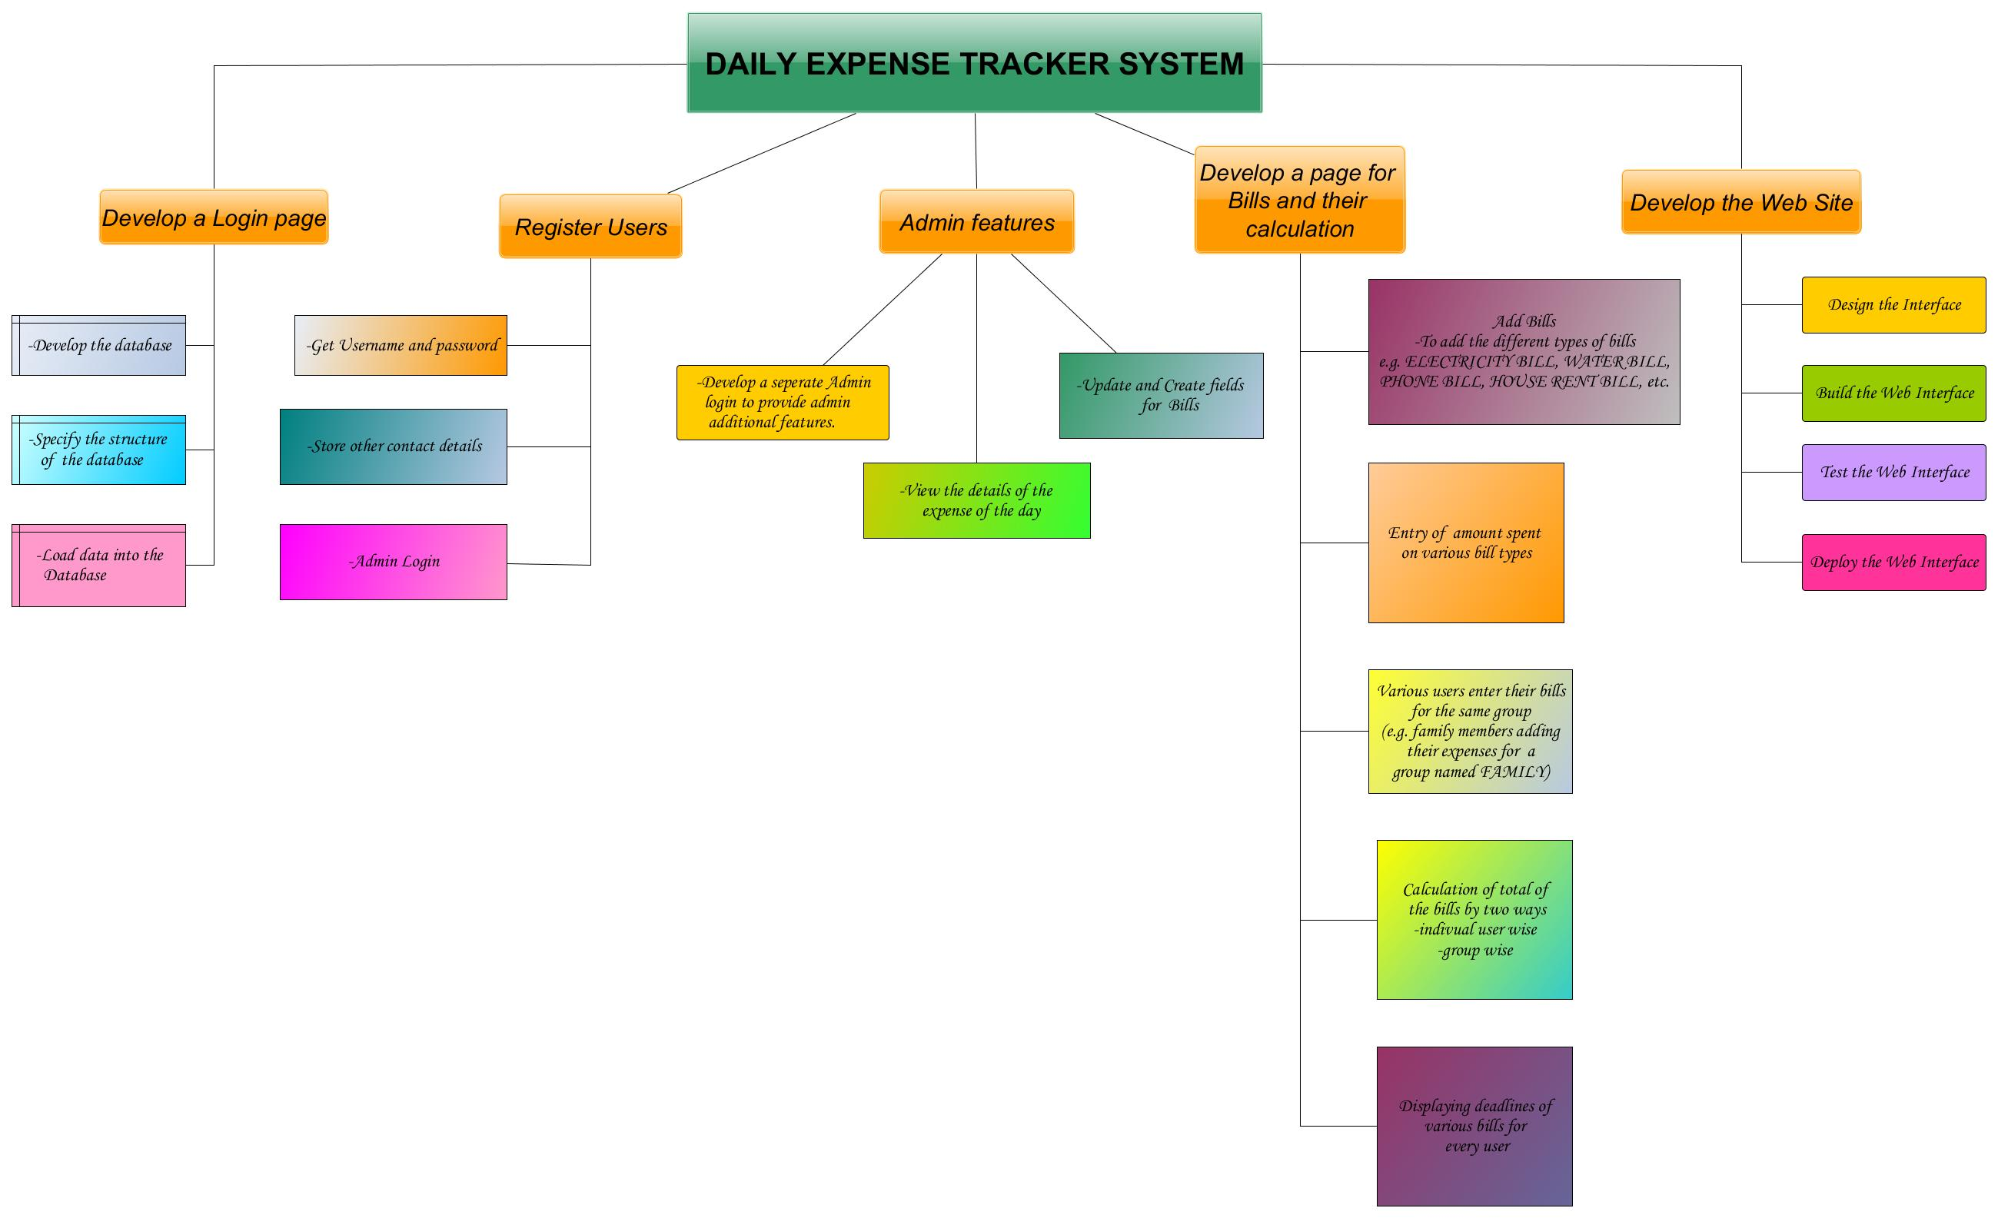

**SEQUENCE DIAGRAM**

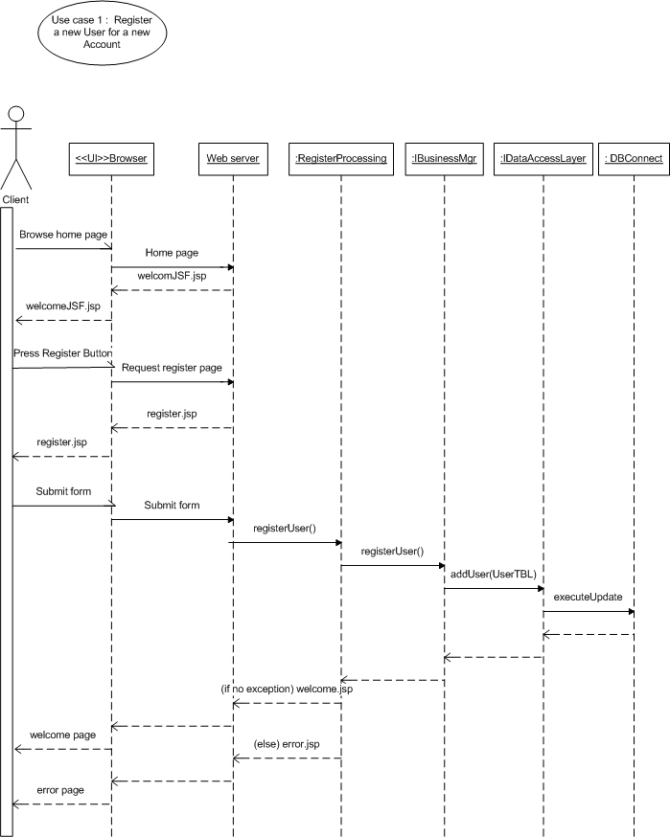

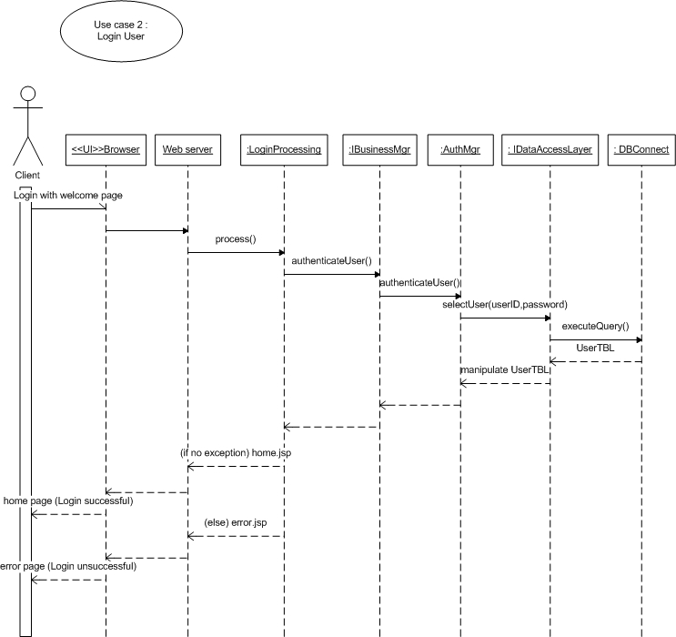

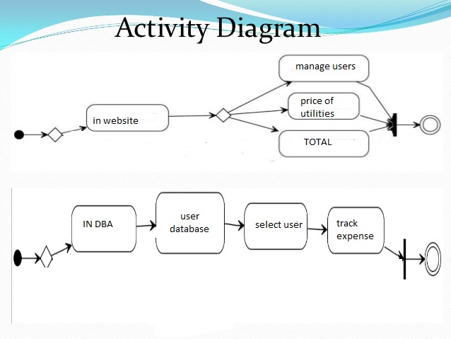

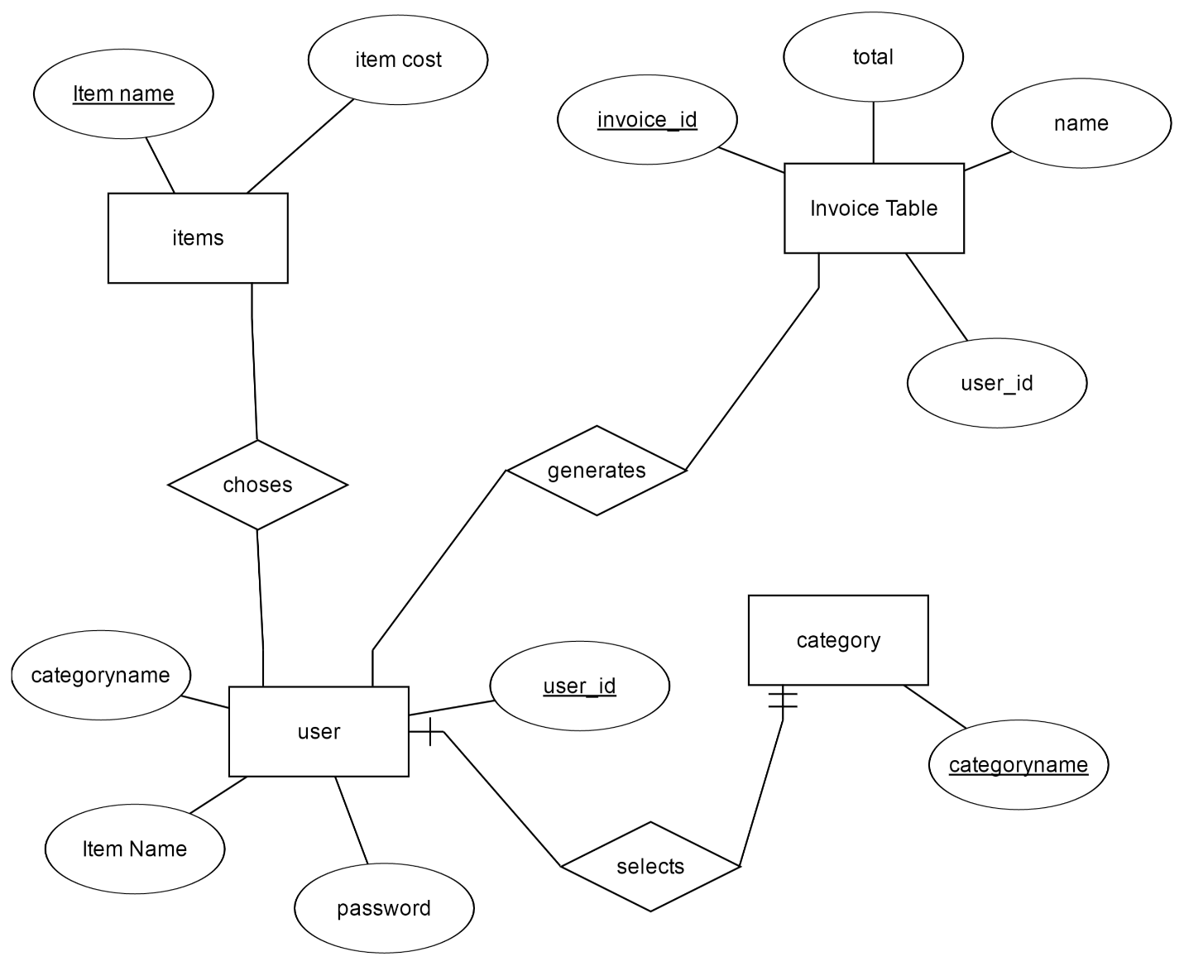**ER DIAGRAM**

**USE CASE DIAGRAM**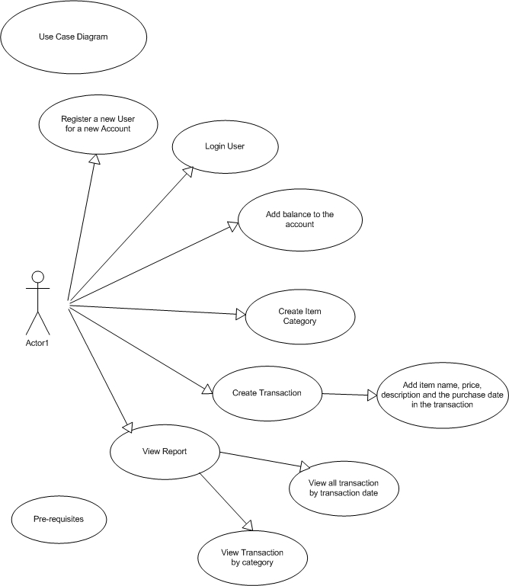

**1. Brief Description**

This use case describes the working of the Daily Expense Tracker System Application.

**2. Actors**

**2.1 User 2.2 Admin**

**3. Preconditions**

**3.1** The server is online/offline.

**3.2** User has already registered on the application/website.

**4. Basic Flow of Events**

**4.1** User fills username.

**4.2** User is validated.

**4.3** Webpage displays actions available on the user’s home page.

**4.4** Customer selects Bills.

**4.5** Website prompts View Bills and Edit Bills.

**4.6** Customer selects a choice.

**4.7** Website prompts Add Bills.

**4.8** Customer enters the data.

**4.9** Information gathered for the generation of total amount of bills and future bills.

**4.10** Customer verifies the bills.

**4.11** Bills is successfully saved.

**4.12** Total amount of bills and other user details are shown to admin.

**5. Alternative flows**

**5.1 User is not validated**

Website displays error message.

**5.2 User goes back to modify the order**

Website deletes the current data and starts the process again.

**6. Key Scenarios**

**6.1 No Response from Server**

**7. Post-conditions**

**7.1 Successful Updation of Bill**

The user will be able to view the bills

**7.2 Failure Condition**

The logs have been updated accordingl

**CLASS DIAGRAM**



**SOFTWARE AND HARDWARE REQUIREMENTS**

1. SQL SERVER Management
2. MINIMUM Internet Explorer 5.0 AND ABOVE, Google chrome, Mozilla Firefox etc.
3. Min. 1GB RAM

**IMPLEMENTATION**

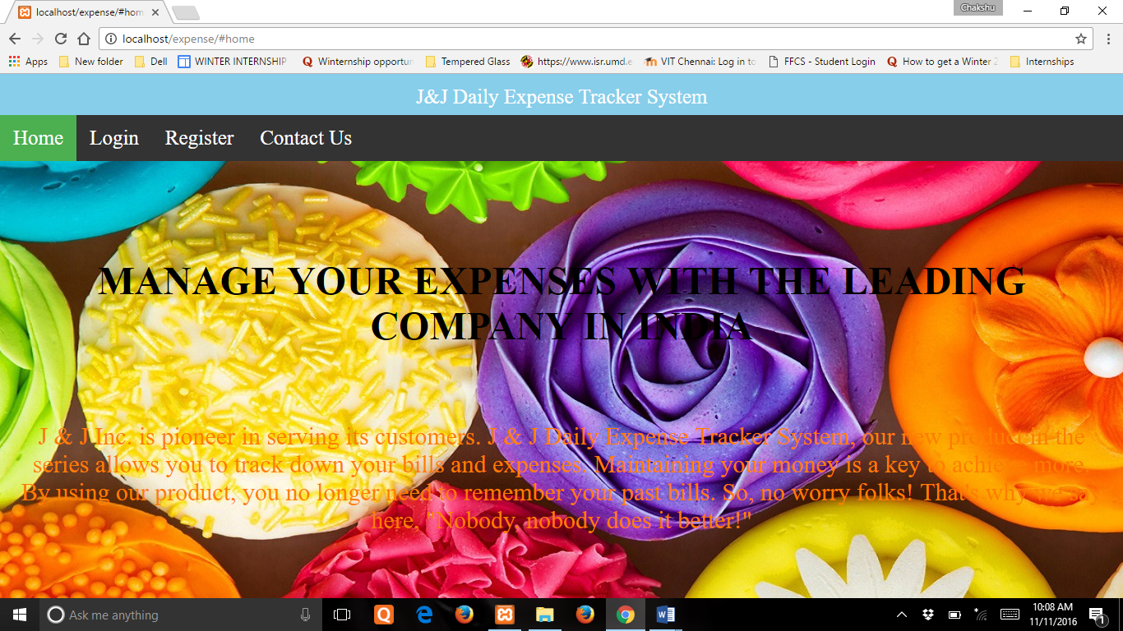

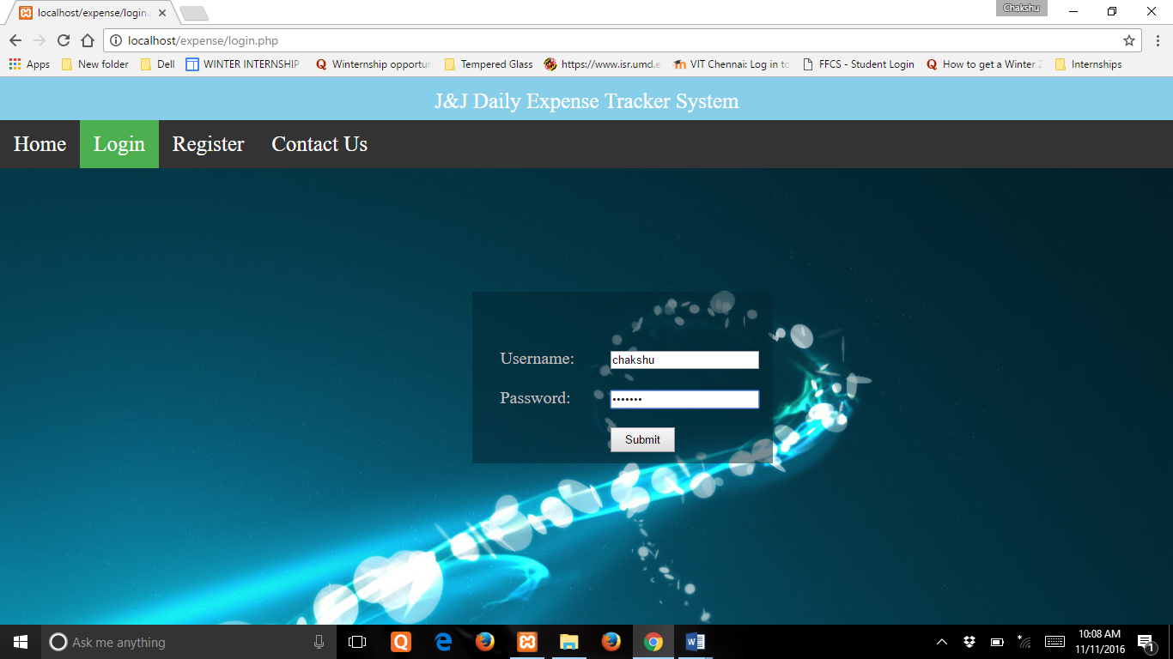

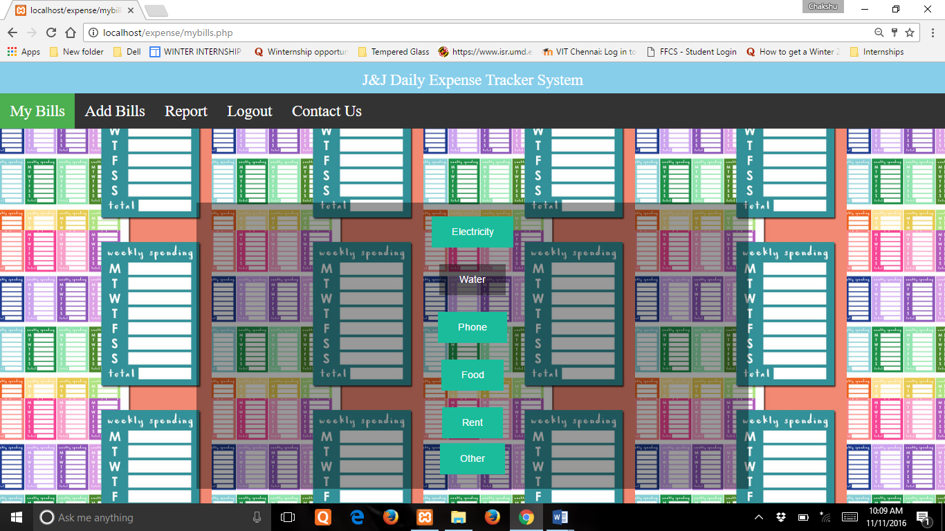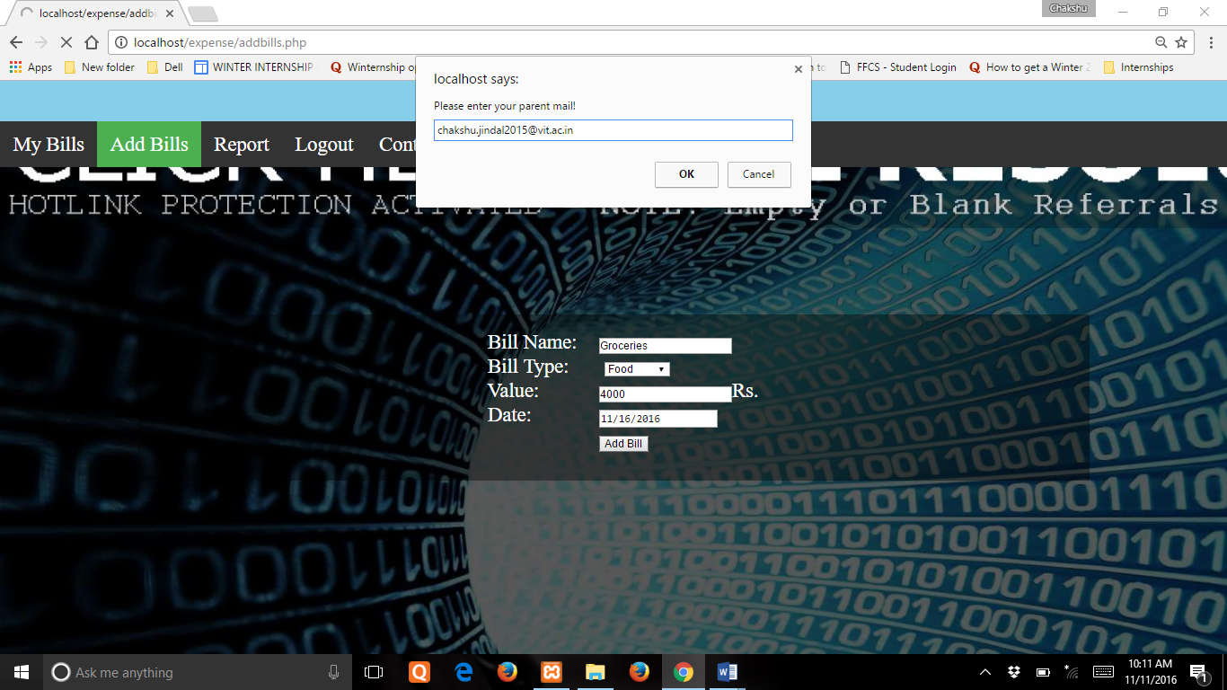

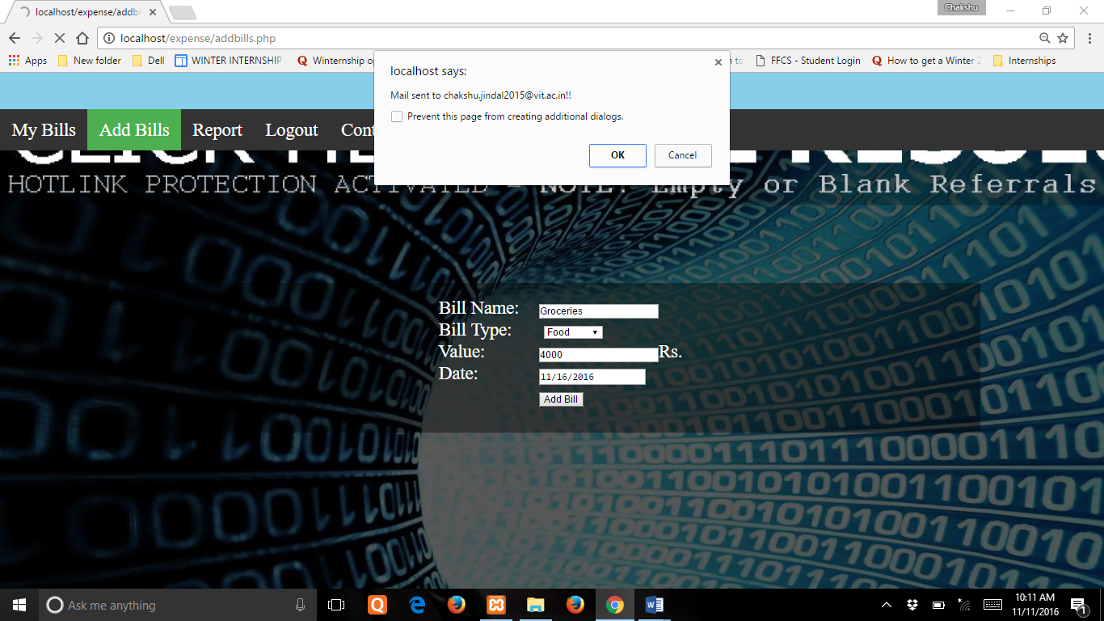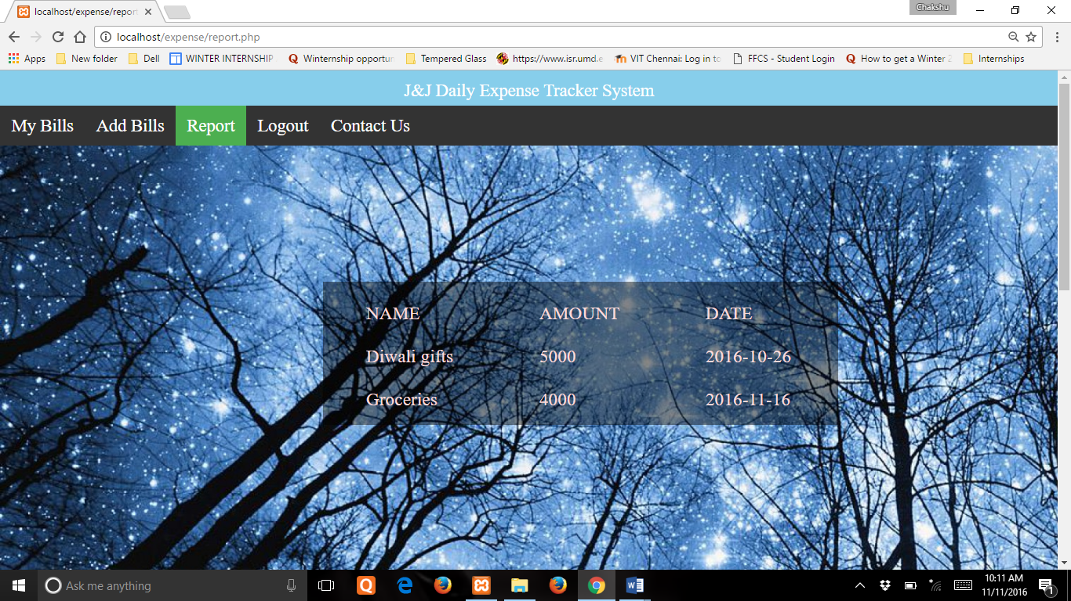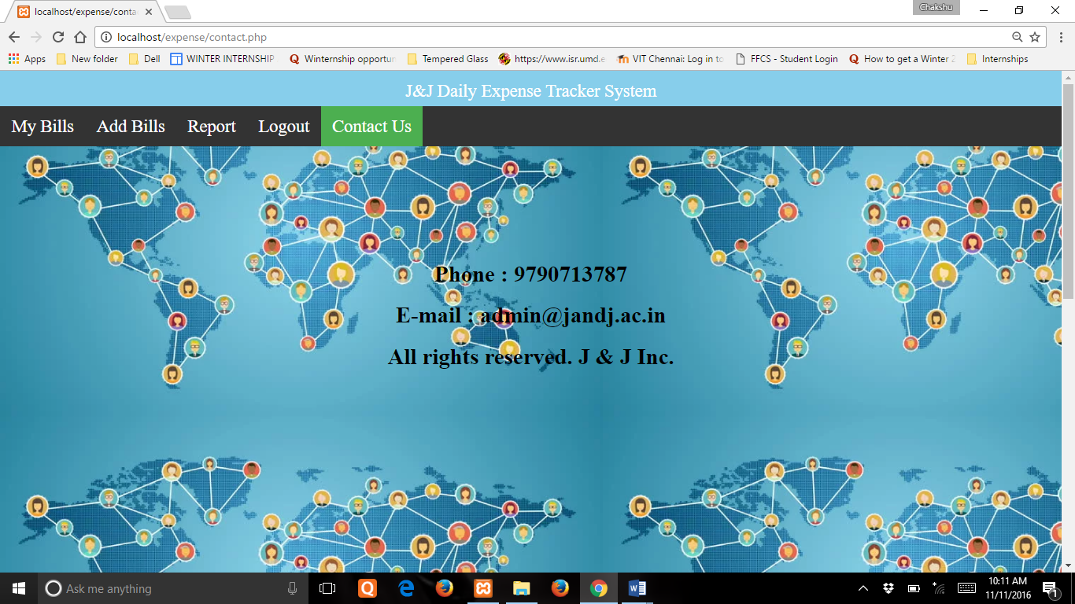

**CYCLOMATIC COMPLEXITY**

We used an online software analysis tool to calculate the efficiency and software metric of the system, and the following are the automate results shown when we input our source code files.

1. Total Mental Effort :

E = 3811715 + 596754 + 372762 + 80145 + 111964 + 172774 + 1500366

= **6646480 Elementary Mental Discriminations**

1. Halstead Software Development Time

T = E / β (β = 18 EMD/Sec)

= 6646480 / 18 = 369248.88 Sec

**= 102.57 hours**

1. Total Program Volume

V =18065+6939+6318+2055+4868+3526+10794

= **52565 bits**

1. Total Lines Of Code (LOC)

LOC = 301+198+144+146+132+101+99

= **1121 LOC**

1. Total Program Difficulty

Ḓ = 211+86+59+39+23+49+139

**Ḓ = 606**

1. Program Level

Ḽ = Ḓ−1

= 1 ÷ 606

= 0.00165016501 (0 <Ḽ< 1)

1. Language Level

Halstead hypothesized that, if the programing language is kept fixed , as V* (Potential

Program Volume) increases , Ḽ decreases in such a way that the product (Ḽ x V*)

always remains constant. Thus this product, which he called the programing language level λ , can be used to characterize the programing language , asserting the efficiency of the code.

λ = Ḽ x V*

= Ḽ2x V

= 0.00165016501 2 𝑥 52565

=**0.14313683787** (est. value 0.1434)

#### % deviation = = 18.35 %

8. Code Efficiency ζ= 100 - % Deviation

= 100 – 0.1835 = **81.65 %**

### **TESTING**

Software testing is a critical element of software quality assurance and represents the ultimate review of specification, design and code generation.

OBJECTIVES OF TESTING

* Testing is a process of executing a program with the intent of finding an error.
* A good test case is one that has a high probability of finding an as-yetundiscovered error.
* A successful test is one that uncovers an as-yet-discovered error.

#### 5.1 Sample Equivalence Class test cases for login id and password

|  |  |  |  |
| --- | --- | --- | --- |
| Test Case ID | Purpose | Test Cases | View following result |
| 1) | Authentication | Maximum 10 character valid-id / available in database. (1) | ID accepted |
| 2) | Authentication | Maximum 10 character valid-id / not available in database | Please enter valid details |
| 3) | Authentication | ID with spaces in between | Please enter valid details |
| 4) | Authentication | ID left blank | Please enter valid details |
| 5) | Authentication | ID with special characters at beginning | Please enter valid details |
| 6) | Authentication | ID with special characters in between | Please enter valid details |
| 7) | Authentication | ID with length less than minimum length | Please enter valid details |
| 8) | Authentication | ID with length more than 10 characters | Please enter valid details |
| 9) | Authentication | ID with spaces at | Please enter valid |
|  |  | beginning | details |

|  |  |  |  |
| --- | --- | --- | --- |
| Test  Case ID | Purpose | Test Cases | View following result |
| 1) | Authentication | Maximum 10 character valid password/available in database(staff) | Accepted |
| 2) | Authentication | Password with blank spaces at beginning | Please enter valid details |
| 3) | Authentication | Password with blank spaces at end | Please enter valid details |
| 4) | Authentication | Password with special characters at any position | Please enter valid details |
| 5) | Authentication | Password with blank spaces in between | Please enter valid details |

|  |  |  |  |
| --- | --- | --- | --- |
| Test Case | **Excepted Result** | **Test Result** |  |
| Enter valid name and password & click on login button | Software should display main window | Successful |  |
| Enter invalid | Software should not display main window | successful |  |
|  |  |  |  |
| **Test Case** | **Excepted Result** | **Test Result** |  |
| On the click of ADD button | At first user have to fill all fields with proper data , if any Error like entering text data instead of number or entering number instead of text..is found then it gives proper message otherwise Adds Record To the Database | successful |  |
| On the Click of SUBMIT  button | Display the next form | successful |  |

|  |  |  |  |  |  |  |  |  |  |  |
| --- | --- | --- | --- | --- | --- | --- | --- | --- | --- | --- |
| **S.No** | **Requirment number** | **test case id** | **description of test case** | **expected reslt** | **actual result** | **priority** | **severity** | **status** | **comments** | |
| 1 | 1 | 1 | the field has 3 modules | it as 3 modules |  | high |  |  |  |  |
|  |  |  |  |  |  |  |  |  |  |  |
| 2 | 2 | 2 | the first form has 4 fields | it has 4 fields |  | high |  |  |  |  |
|  |  |  |  |  |  |  |  |  |  |  |
| 2.1 | 2.1 | 2.1 | this form has a text box to type user name | text box exists |  | high |  |  |  |  |
|  |  |  |  |  |  |  |  |  |  |  |
| 2.2 | 2.2 | 2.2 | this form has a text box to type the password | text box exists |  | high |  |  |  |  |
|  |  |  |  |  |  |  |  |  |  |  |
| 2.3 | 2.3 | 2.3 | a button to admit all the inputs are to verified "OK" | a button exists |  | high |  |  |  |  |
|  |  |  |  |  |  |  |  |  |  |  |
| 2.4 | 2.4 | 2.4 | a back button should be provided to get into previous page | the button exists |  | high |  |  |  |  |
|  |  |  |  |  |  |  |  |  |  |  |
| 3 | 3 | 3 | the user name text box is only allowed to accept a input size of 4 to 6 .  Ex:(absD) | accepts the expected size of username string | | high |  |  |  |  |
|  |  |  |  |  |  |  |  |  |  |  |
| 4 | 4 | 4 | the password field should only accept a size of 5 and that must be an  array of numbers Ex:(45316) fails at "fgd@#5855" | accepts only a "5" digit number "21345" |  | high |  |  |  |  |
|  |  |  |  |  |  |  |  |  |  |  |
| 5 | 5 | 5 | if the "OK" button is pressed the next form should appear | the buttons directs to another page |  | high |  |  |  |  |
|  |  |  |  |  |  |  |  |  |  |  |
| 6 | 6 | 6 | the user name text box doesn’t allow the input "s55f^&56s" | the input is rejected |  | high |  |  |  |  |

**CONCLUSION**

The system we envisioned comes to practise, providing a centralised log inculcating all daily expenses. No or less manual calculations are required by the user, with efficient and user friendly interface.

Followings are some future development plans

* Group: Apart from keeping a personal log, we are planning to extend this system to incorporate a shared expense group.
* Payment gateway: We are planning to include a service so as to make the direct cash payment within the application itself.
* Representing the interface multilingual

**REFERENCES**

1. www.google.com/how_to_calculate_expense/

2. www.fadooengineers.com/software_testing/

3. www.wikipedia.com/calculation_of_expense/